ANCIENT SETTLEMENTS OF WISCONSIN

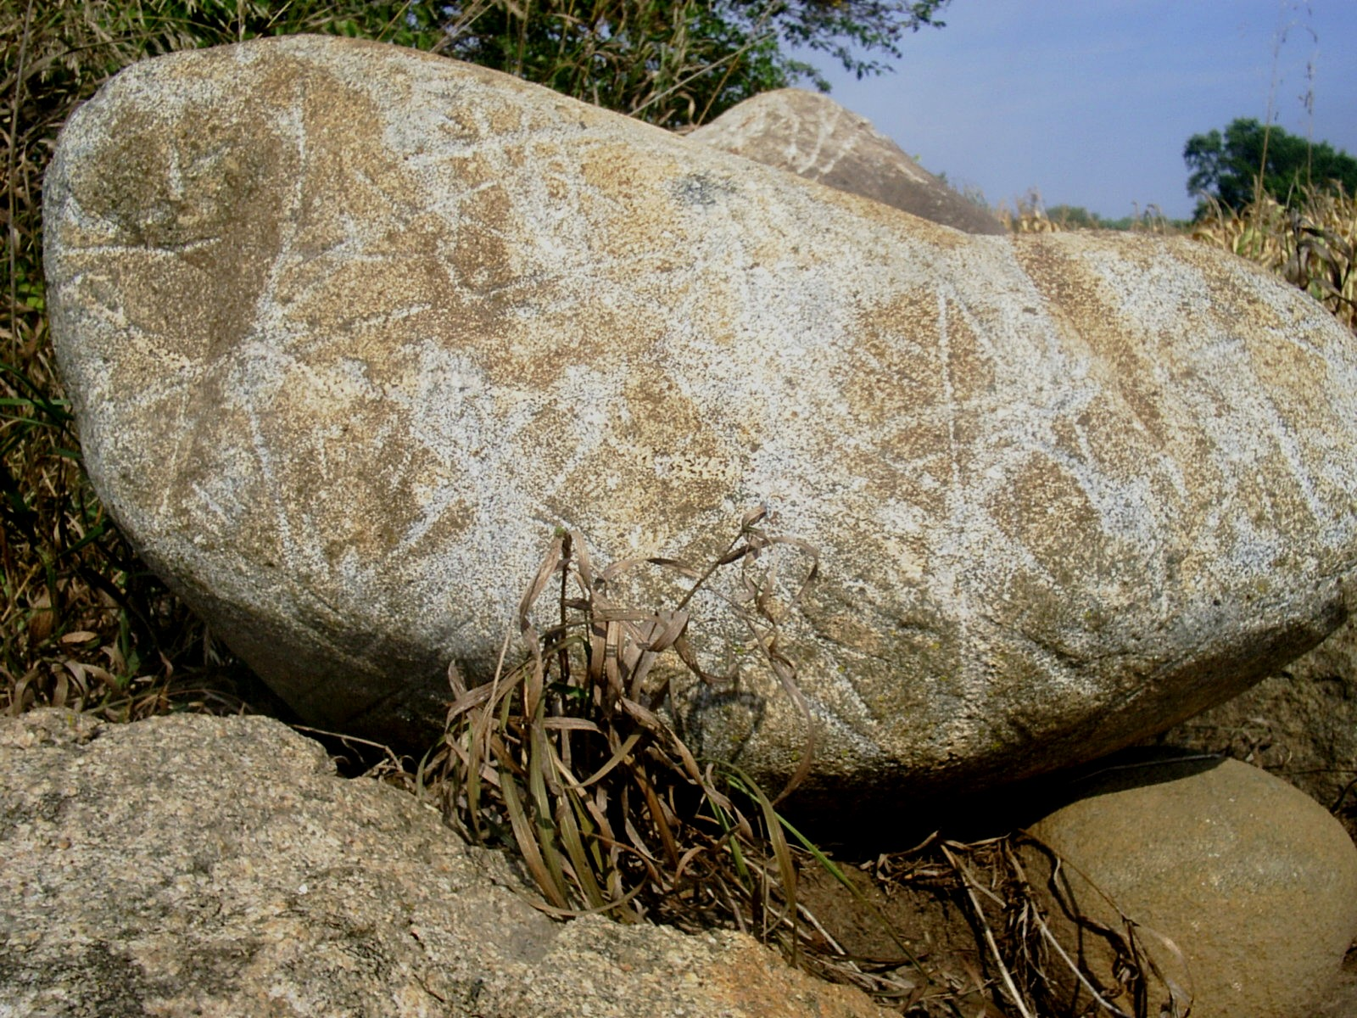

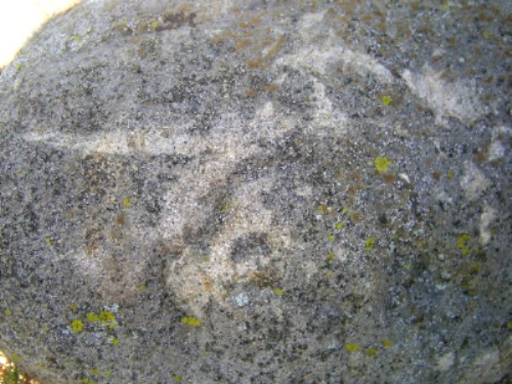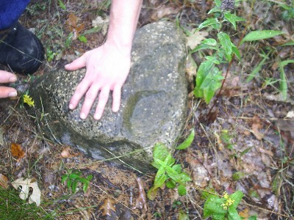

There is a great deal of evidence that entire parts of the Midwest, including parts of Iowa, Minnesota, and Wisconsin, were thoroughly submerged in an ice-melt ocean at the end of the last ice age. There is also considerable proof that the area had been settled by what appear to be a Viking-like people centuries, and even millennia, before what the "authorities" will admit.

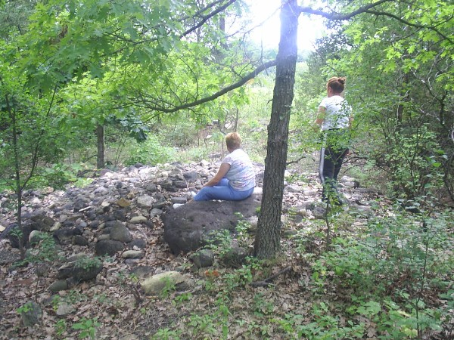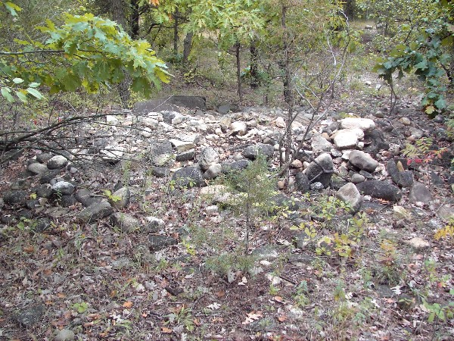

Ships were brought in on the ancient shorelines and settlements were built. Various shoreline levels are evident throughout the area, most likely as a result of both slow drainage of the inland sea over time, and geological instability that caused entire regions to subside and change water levels.

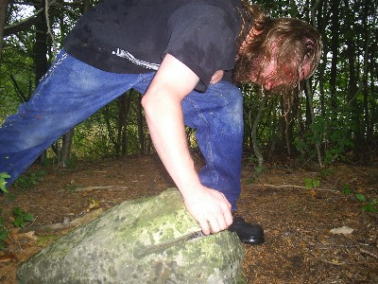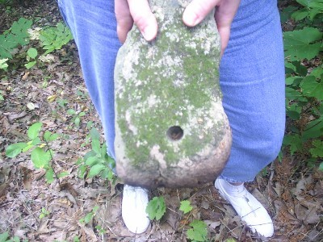

Many of the stones and boulders along this shoreline were inevitably used as "mooring stones" to anchor boats or fly ceremonial or territorial flags. Invariably, these obvious mooring holes have been labeled as "blasting holes" by those responsible for informing the public of their archaeological significance, thus many have been entirely destroyed. In many cases, the sites were used as not only as boat docks, but lodging, ceremonial purposes, funerary burials, and for storage. Using sophisticated electromagnetic instruments, researchers have been able to locate the outline of structures, including longboats, beneath the ground at many sites.
(See Orval D. Friedrich’s books on early Vikings in the New World in the bibliography.)

Since we’re on the subject of Vikings, let’s talk about a large runestone, resembling a Viking ballast stone, that was found near Kensington, Minnesota, by a farmer named Olaf Ohman. The "Kensington Runestone," as it is known, weighs 202 pounds and measures 6 inches thick, 16 inches wide, and 31 inches long. On November 8th, 1898, Ohman claims he was trying to remove a 40-year-old aspen tree from his property and when it finally came up the monolith was tangled in its roots. This would seem to indicate that it had been inscribed long before Ohman found it, since he was just settling the land. After he found it, and local authorities showed little interest in it, he used it as a doorstep outside of a farm building. Luckily for us, he placed it face down.

A number of years had passed, and a student from the University of Wisconsin, Hjalmar Holand, heard of the stone. When he first asked to purchase it, Ohman wanted ten dollars, but the young student could only afford five, so Ohman just gave him the stone. Holand was then able to make what appears to be an accurate translation (without the punctuation) in 1909:

"8 Goths and 22 Norwegians on exploration journey from Vineland round about the west. We had camp by [a lake with] 2 skerries 1 days journey north from this stone. We were [out] and fished one day. After we came home [found] 10 red with blood and dead. AV[e] M[aria]. Save [us] from evil."

And along the edge of the stone was inscribed: "Have 10 of [our party] by the sea to look after our ships. 14 days journey from this island. Year 1362."

It should be mentioned that some authorities believed that the stone had been forged by Ohman, but if that is indeed the case, he most surely did not profit from it. There have been a number of books that have written about the Kensington Runestone. The stone itself can still be found, eminently displayed, in the city of Alexandria, Minnesota.

ROCK LAKE

There has been a number of good books written on the mysteries beneath Rock Lake. It has an interesting history, in that inventor Max Gene Nohl tested a revolutionary innovation in this small Wisconsin lake that would forever change underwater exploration. The year was 1937 and Nohl had been interested in the Rock Lake mystery since pilot Dr. Fayette Morgan reported seeing underwater structures the previous year. He decided to field-test his Self Contained Underwater Breathing Apparatus, better known these days as S.C.U.B.A. gear, to try and confirm the report. He claims to have found a conical rock pyramid submerged in about 40 feet of water measuring about 29 feet high with an 18-foot wide base.

In more recent times, a number of other underwater structures have been discovered in this lake which resemble other pyramid-like constructions found throughout North America. Though currently unconfirmed, one of the largest underwater structures was said to measure about 50 feet by 70 feet by 25 feet. Some of the smaller structures have square corners formed from straight edges. There is evidence that smoothly-mortared stones were used in some of the pyramids, and broken clam shells and split bones were found near others, similar to articles found near Aztalan.
(Source: Ted St. Rain, Mystery of America)

